SDLC:

Task: 1

What is SDLC?

SDLC refers to software development lifecycle . in software development the whole process how the software is made using various steps such as developing , deployment , testing and many more. SDLC is lifecycle from gathering the information to testing and deployment of software. It even has steps such as testing .In testing it has black box testing , white box and many more testing techniques. SDLC is whole lifecycle of software for start to end

Task 2

Why is SDLC ?

It is a step by step process to create software .which is important for developing . it makes all the development to deployment task easier , the steps In SDLC makes it simple to understand what is the process of the development and what it needs to be done. Step by step procedure to develop the software.

Task 3

What are the stages of SDLC ? write 2 lines about each.

Stages of SOFTWARE DEVELOPMENT LIFE CYCLE :

1.Planing : how to create the project . where should it start how to proceed with the solution with the question. Gather information for the software accruing to requirement

2. requirement : what are the requirement for the project such as technical , functional requirement.

2. design : to design the software . which is easier to use, user friendly.(blue print of the software).Creating the architecture of the software

3, development .: to start create the software

4. testing : to test whether the software is up to the mark in technical and functional requirements. To test how the software is working

5. deployment & maintain : to deploy the software , so it is available to the consumer/ clients to use . to deploy the software to cloud so the clients/consumer can use it, and the maintaining of the software. To maintain the software it there are any issue with the software or upgrade any of the function required

Models for the SDLC

1. WATERFALL MODEL . : it is sequential and linear model where each step must be completed before the next step begins, we cannot overlap the steps in the waterfall model , the previous steps need to be completed

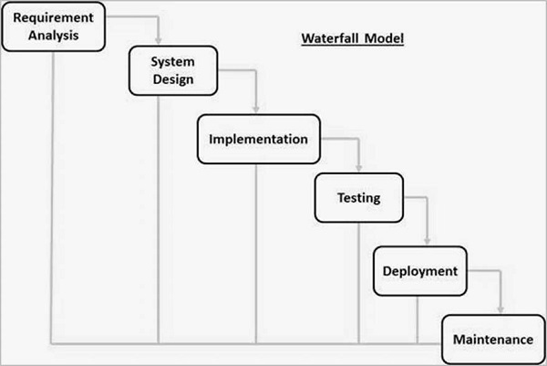

The best example of water fall model in day to day life is building the house .in building the house the each step is completed before the another step begins

Advantage :

Easy to use and understand

disdvantage :

struggles to make changes after the project is completed

costly to make changes

## 2. Incremental Model

In this the software development approach that breaks down a project into smaller, manageable modules or increments. In this each increment goes through all the phases of the software development life cycle .

Application : construction of car . The car started with the a frame structure and then gradually added parts until it was finished.

Advantage :

Easy to detect error , because each of the development step is tested , easy to manage

Disadvantage:

Difficult in making changes

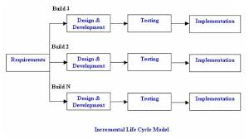

3.Agile Model: In the agile model, the software product is divided into small incremental parts. In this, the smallest part is developed first and then the larger one.

* 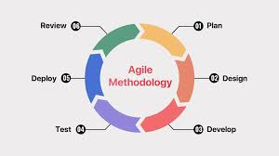

The of any of the application any apps where the teams build a new app, they often divide the work into short phases. This allows them to add new functions bit by bit, try out what users like and then improve it directly. They can react quickly to new user requests or changes in the market.

Advantages :

flexibility, faster feedback, and customer satisfaction

disadvantage :

high cost , depends on the customer feedback

Agile relies heavily on customer input and availability, which can be a challenge if the customer is not readily available or responsive.

## 4.V-Model : the execution of each process is sequential, that is, the new phase starts only after the previous phase ends.

The V-Model is a Software Development Life Cycle (SDLC) model that emphasizes testing and validation throughout the development process. It's particularly well-suited for projects with clear requirements and a need for rigorous quality assurance, like those in regulated industries or those involving complex software

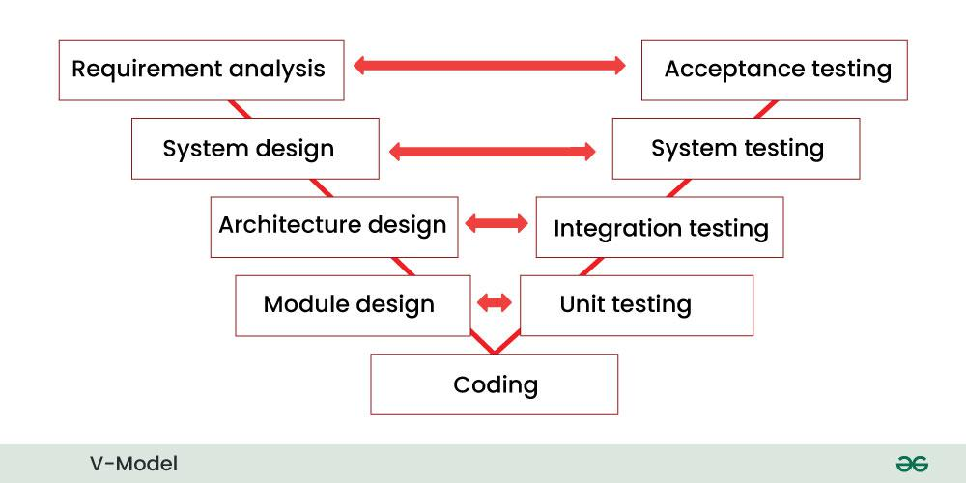

This model is used in the medical development field, as it is strictly a disciplined domain.

Advantage :

Simple to use , easy to understand , cost effective

Disadvantage ;

Not good for complex projects , poor for long and ongoing projects , hard to go back In the previous stages and make changes for the previous steps.

SCRUM: It is a framework within Agile which is used to work and collaborate with the teams. it is used to breakdown the problems into smaller parts so that is easy to understand. It allows to continuous adaptation and improvement.

Sprints : sprint is a fixed-length period of time during which a team works to complete a set of work and deliver a potentially releasable product increment.

To does during sprints

1. Provide feedback

2.Proritize work goals

3.include input from previous sprints

TO NOT TO DO DURING SPRINT WORK

1.DONT RUSH FOR THE GOALS

2.DONT CHANGE THE SPRINT GOALS

3. DON’T NEGLATE THE PREVRIOUS INPUT OR RESULT FROM THE PREVIOUS SPRINTS /DON’T OVERLOAD THE TEAMS

BACKLOG : prioritized lists of work items that need to be done to deliver a product or service

STORIES : small, independent units of work that represent a user's need or goal

Increment : The Increment is the result of a Sprint, containing all the completed Product Backlog items that meet the Definition of Done

Scrum, artifacts

In Scrum, artifacts are key pieces of information used by the team and stakeholders to track progress, manage work, and ensure transparency throughout the development process. The three main Scrum artifacts are the Product Backlog,

The Sprint Backlog is a subset of the Product Backlog, containing the items that the development team plans to work on during a specific Sprint (a fixed time period for completing a defined amount of work)

The Product Backlog is a prioritized list of all the work that the team needs to do to deliver the product. It's a living document, constantly being updated with new ideas, features, and bug fixes.

A burn down chart is a visual tool that helps teams track their progress on a project by showing the remaining work over time.

NETWORKING

PROTOCLS : The set of rules that devices use to communicate. There are many different protocols for different types of communications. Examples are HTTP (For web browsing) and SMTP (For emails)

PORTS : In computer networking, ports act as communication endpoints, facilitating data transfer between devices and applications. They are software-based and managed by the operating system, allowing a device to handle multiple network connections simultaneously.

Port is **a logical address of a 16-bit unsigned integer** that is allotted to every application on the computer that uses the internet to send or receive data

Network types :

LAN –(LOCAL AREA NETWORK) BUILDING OR OFFICE

MAN – (METROPOLITAN AREA NETWORK)CAMPUS

WAN –(WIDE AREA NETWORK) BIGGER GEOGRAPHICAL AREAS SUCH AS COUNTRIES

VPN –(VIRTUAL PRIVATE NETWORK) CREATES THE VIRTUAL PRIVATE NETWORK

Web Servers: These servers host websites and web applications, delivering web pages to users' browsers.

Database Servers: Dedicated to storing and managing data, often using database management systems (DBMS).

FTP Servers: Enable file transfers between computers using the File Transfer Protocol.

Game Servers: Host and manage online multiplayer gaming sessions.

Mail Servers: Handle the sending, receiving, and storing of email messages.

File Servers: Provide centralized storage and sharing of files across a network.

DNS Servers: Translate domain names (like google.com) into IP addresses.

DNS :

The Domain Name System (DNS) acts as a translator for the internet, converting human-readable domain names like "google.com" into the numerical IP addresses that computers use to communicate

Network Topologies

Network topology describes the physical and logical layout of a network, outlining how devices and connections are arranged.  It dictates how data flows between devices and impacts performance, security, and scalability. Understanding network topology is crucial for designing, managing, and troubleshooting computer networks

1 star topology :

Devices are connected to a central hub or switch.

all network devices connect to a central hub or switch, creating a network structure that resembles a star

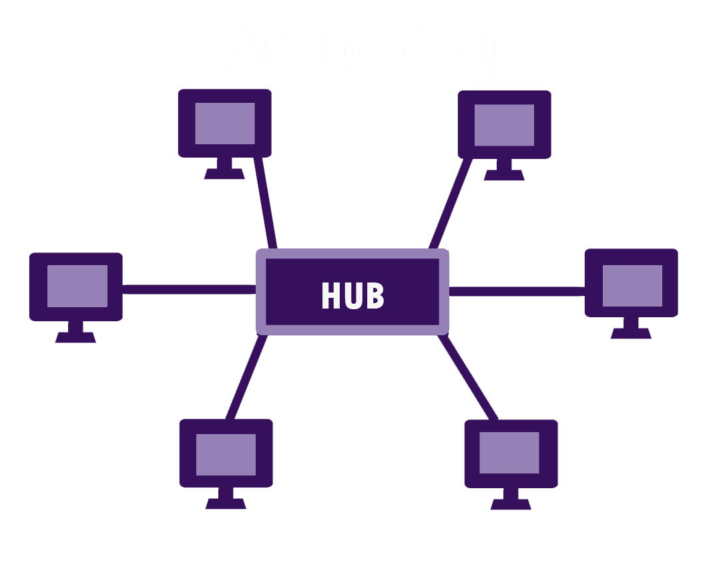

1. Bus Topology :

Devices are connected to a single backbone cable.  all network devices connect to a single, shared cable or backbone, resembling a bus with stations along the way.

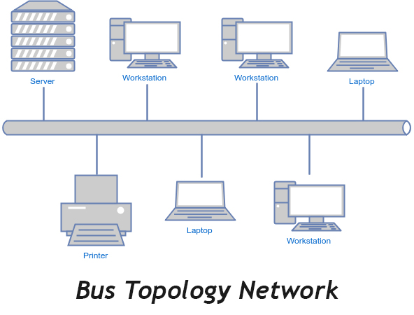

Ring topology : Devices are connected in a circular path, where data travels in one direction. network devices are connected in a circular loop, creating a closed path for data transmission

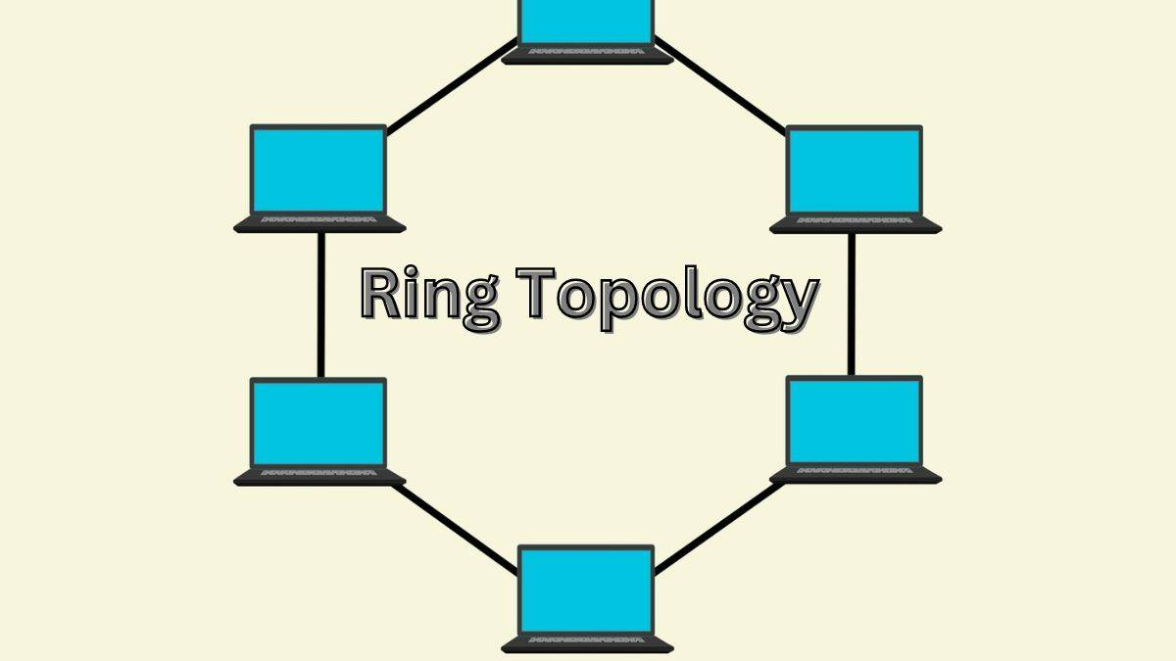

MEST TOPOLOGY :

a mesh topology is a decentralized network where devices connect to multiple other devices, forming a network with redundant paths. This contrasts with centralized networks that rely on a central hub or switch

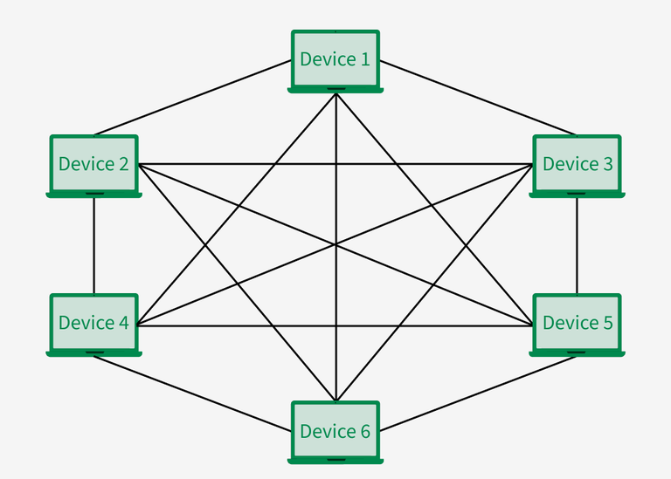

TREE TOPOLOGY

a tree topology organizes network devices hierarchically, similar to a tree's structure with a root node and branches. It's a hierarchical structure where the root node connects to multiple child nodes, which can also have their own child nodes, creating a layered hierarchy

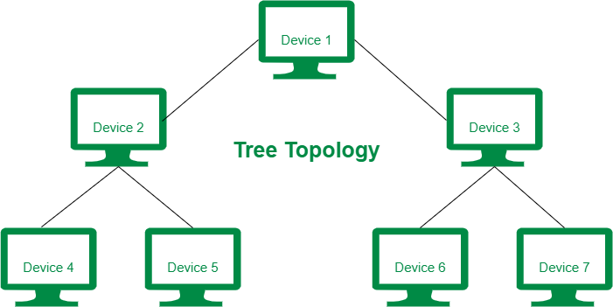

OSI MODEL :

The OSI model is a conceptual framework that describes how network communications work. It divides network functionality into seven distinct layers, each with specific responsibilities.

Layers of OSI MODEL

1.Physical Layer :This layer deals with the physical transmission of data,  It defines how data is encoded into signals and transmitted across the network.

2. Data Link Layer :

This layer handles the establishment and termination of connections between two physically connected nodes on a network. It also performs error detection and correction within the physical layer and uses protocols like Ethernet.

3.Network Layer:

This layer is responsible for routing data packets between different networks or subnets. It uses protocols like IP (Internet Protocol) to address and deliver data across the network

4.Transport Layer :This layer provides reliable data transfer between applications, ensuring data integrity and delivery. It uses protocols like TCP (Transmission Control Protocol) and UDP (User Datagram Protocol) to control the flow of data.

5. Session Layer (Layer 5): This layer manages the communication sessions or connections between applications. It establishes, maintains, and terminates connections between two applications, handling authentication and authorization.

6. Presentation Layer (Layer 6): This layer is responsible for formatting, translating, and encrypting data for presentation to the application layer. It ensures that data is presented in a format that the application can understand, handling issues like encryption and decryption.

7. Application Layer (Layer 7): This layer is the highest layer and provides the interface between the network and the end-user applications. It includes protocols like HTTP (Hypertext Transfer Protocol), SMTP (Simple Mail Transfer Protocol), and FTP (File Transfer Protocol), which are used by applications to interact with the network.

